**Assignment 1**

1. **Print Hello World:**

#Laboratory Exercise 5, Assignment 1

.data

test: .asciiz "Hello World"

.text

li $v0, 4 #service 4 is print String

la $a0,test #the String to be printed is Hello World

syscall #execute

Text Segment:

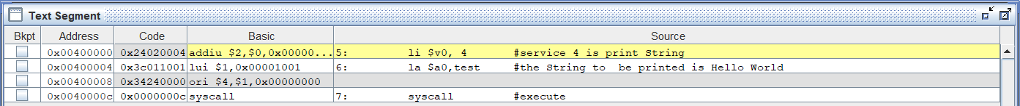

Sự thay đổi của các thanh ghi:

$v0: 0x00000000 -> 0x00000004

$at: 0x00000000 -> 0x10010000

Kết quả:

